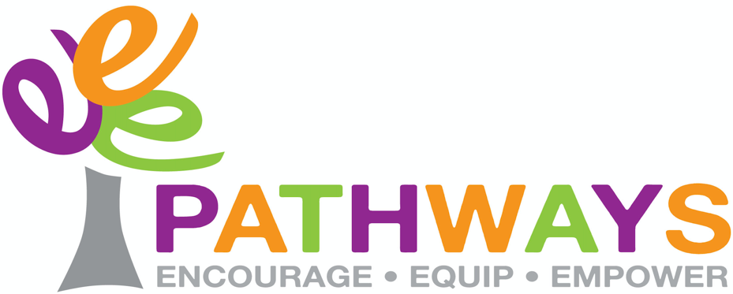

www.pathwaysjersey.co.uk
Email:hello@pathwaysjersey.co.uk

BOOKING FORM FOR PATHWAYS HOLIDAY CLUBS 2025 - 2026

Our Holiday Clubs are led by a group of young people who have come together because they are passionate about leadership and the desire to serve others.

These young people are encouraged to organise and plan the holiday clubs focussing all games, crafts and activities around a film that is watched during the time together. The young people excel in building relationships with the children, playing games, learning action songs, helping children develop skills through the various crafts and encouraging them to do their very best. At the end of the holiday clubs every child takes home a bag full of crafts.

If you would like your child to attend a Pathways Holiday Club then please indicate on the booking form below. Provisional bookings can be made in advance but if your circumstances change and you no longer need the booking, then please let us know as soon as possible so that another child can be offered the place. We ask that payment is made before the start of the required club. Every child will need a registration form completed to give us up to date contact and medical details should we need to get in touch with you urgently. Our Holiday Club remains at the very affordable price of £20 per day.

Please complete the booking form and registration form to 35 Les Quennevais Park, St Brelade JE3 8GB or alternatively scan a copy to hello@pathwaysjersey.co.uk. Payment to be made preferably by bank transfer.

We look forward to building a relationship with you and your children.

Best wishes

The Pathways Team

PATHWAYS HOLIDAY CLUB BOOKING FORM 2025 - 2026

Name of child/children _________________________________________________

HOLIDAY CLUB | COST PER CHILD | MONT NICOLLE  SCHOOL | ST LUKE’S  SCHOOL
OCTOBER HALF TERM  Monday 27th & Tuesday 28th October 2025 | £40
CHRISTMAS HOLIDAYS  Monday 22nd & Tuesday 23rd December 2025 | £40
FEBRUARY HALF TERM  Monday 16th & Tuesday 17th February 2026 | £40
EASTER HOLIDAYS  Tuesday 7th to Friday 10th April 2026 | £80
MAY HALF TERM  Tuesday 26th May & Wednesday 27th May 2026 | £40
SUMMER HOLIDAYS  Monday 20th July to Friday 24th July 2026 | £105

Payment can be made by bank transfer. Details as follows:
Account Name: Pathways Account No: 27285006 Sort Code: 60-12-03
Please ensure you include your child’s name as reference for payment.

Alternatively cheques made payable to “Pathways” and sent to 35 Les Quennevais Park, St Brelade, JE3 8GB

If you have any further queries then please don’t hesitate to contact us by email hello@pathwaysjersey.co.uk or mobile 07797 780 155

